MATHEMATICS METHODS

MAWA Semester 1 (Unit 3) Examination 2018
Calculator-assumed

Marking Key

© MAWA, 2018
Licence Agreement
This examination is Copyright but may be freely used within the school that purchases this licence.
- The items that are contained in this examination are to be used solely in the school for which they are purchased.
- They are not to be shared in any manner with a school which has not purchased their own licence.
- The items and the solutions/marking keys are to be kept confidentially and not copied or made available to anyone who is not a teacher at the school. Teachers may give feedback to students in the form of showing them how the work is marked but students are not to retain a copy of the paper or marking guide until the agreed release date stipulated in the purchasing agreement/licence.

The release date for this exam and marking scheme is
- the end of week 8 of term 2, 2018

Section Two: Calculator-assumed (100 Marks)

Question 9 (5 marks)
Solution
Mathematical behaviours | Marks
- uses (0,- 6) to determine d  - differentiates and uses to obtain c  - states and states relationship between a and b  - uses (1,-8) to determine relationship between a and b  - solves simultaneous equations to determine a and b | 1  1  1  1  1

Question 10(a) (4 marks)
Solution
Let $F$ denote the number of questions that Fiona answers correctly, assuming that she is guessing. Then $P(F≥3)$ is probability that Fiona passes.
Similarly, if $G$ denotes the number of questions that Gary answers correctly, assuming that he is guessing, then $P(G≥10)$ is probability that Gary passes.
Now $F\sim B\left(6,1/5\right),$ and $G\sim B\left(20,1/3\right).$
$P(F≥3)≈0.0989$ and $P(G≥10)≈0.0919$
Since the probability that Gary passes via guessing is less than the probability that Fiona passes via guessing, we can say that Gary is luckier.
Mathematical behaviours | Marks
- recognizes the binomial probabilities  - evaluates probabilities  - justifies who is luckier | 1  1+1  1

Question 10 (b) (i) (2 marks)
Solution
Let $L$ denote the number of light bulbs that fail in a random sample of 100. Then $L\sim B(100,0.04)$, if the manufacturer is correct.
Then $P\left(L≥15\right)=1.082×{10}^{-5} (very very small)$
Mathematical behaviours | Marks
- recognizes binomial probability with correct parameters  - states probability | 1  1

Question 10 (b) (ii) (2 marks)
Solution
Because the probability that such a large number of bulbs fail if the manufacturer’s claim is correct, is very, very small, there is strong reason to doubt the validity of the claim.
Mathematical behaviours | Marks
- correct conclusion  - justifies reasoning | 1  1

Solution
Mathematical behaviours | Marks
- recognises and states exponential growth formula for I  - uses relationship  - states solution | 1  1  1
Question 11 (3 marks)

Question 12 (a) (2 marks)
Solution
For each die this occurs with probability 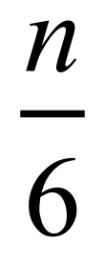
Since the dice are independent, the probability that this occurs both dice is 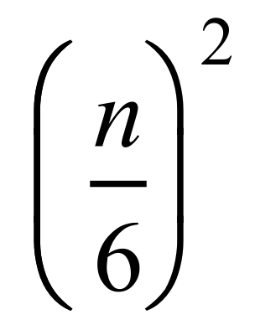

Mathematical behaviours | Marks
- observes that both numbers must be at most n  - uses independence to justify multiplicative formula | 1  1

Question 12 (b) (2 marks)
Solution
From part (a) $P\left(X_{max}≤4\right)=4/9$
So Vanessa’s expected winnings from each $1 she bets is $\$\left(\frac{4}{9}-\frac{5}{9}\right)=-\$\frac{1}{9}$
So her expected return from 100 $1 bets is a loss of $\$\frac{100}{9}≅\$11.11$
Mathematical behaviours | Marks
- correct expected value for a $1 bet.  - correct final answer | 1  1

Question 12 (c) (2 marks)
Solution
$$n$$ | $$P(X_{max}=n)$$
1 | 1/36
2 | 4/36 – 1/36 = 3/36
3 | 9/36 – 4/36 = 5/36
4 | 16/36 – 9/36 = 7/36
5 | 25/36 – 16/36 = 9/36
6 | 36/36 – 25/36 = 11/36

Mathematical behaviours | Marks
- uses subtraction to obtain individual probabilities from the cumulative  ones in part (a)  - correct answers in all 5 outstanding cases | 1  1

Question 12 (d) (2 marks)
Solution
$$n$$ | $$P(X_{max}=n)$$ | $$n×P(X_{max}=n)$$
1 | 1/36 | 1/36
2 | 3/36 | 6/36
3 | 5/36 | 15/36
4 | 7/36 | 28/36
5 | 9/36 | 45/36
6 | 11/36 | 66/36
Directly from calculator, or via:

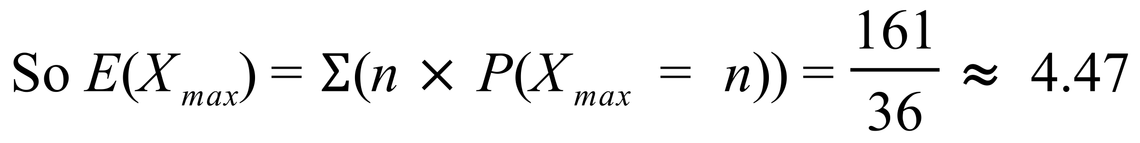
Mathematical behaviours | Marks
- writes a calculation for expected value  - determines expected value | 1  1

Question 12 (e) (2 marks)
Solution
$$n$$ | $$P(X_{max}=n)$$ | $$n^{2}×P(X_{max}=n)$$
1 | 1/36 | 1/36
2 | 3/36 | 12/36
3 | 5/36 | 45/36
4 | 7/36 | 112/36
5 | 9/36 | 225/36
6 | 11/36 | 396/36
Directly from calculator, or via
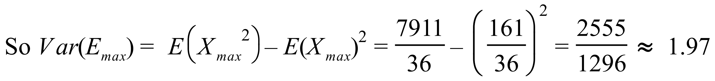
Mathematical behaviours | Marks
- calculates correctly  - calculates variance correctly | 1  1

Question 12 (f) (3 marks)
Solution
If a large number of dice are thrown, m, say, then
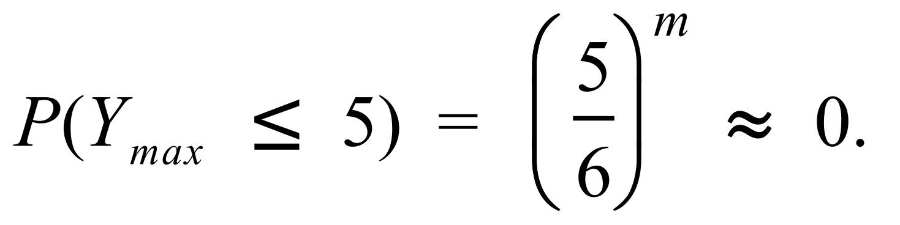
So is almost certainly equal to 6
So
Mathematical behaviours | Marks
- correct answer for 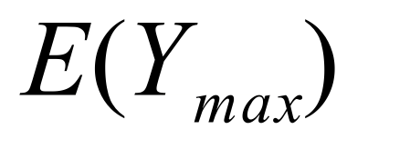  - correct answer for 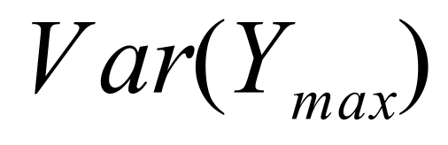 | 1  1  1

Question 13 (a) (4 marks)
Solution
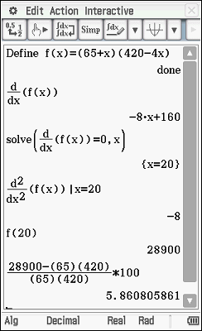
Let $y$ represent the yield from the trees
Let $x$ represent the number of extra trees planted

Macintosh orchard should plant an additional 20 trees
for optimal yield.
Mathematical behaviours | Marks
- clearly identifies variables used in equation  - correct ‘yield’ equation  - differentiates and solves  - justifies that maximum is found and states solution | 1  1  1  1

Question 13 (b) (1 mark)
Solution

Current Yield: 27 300 oranges
Optimal Yield: 28 900 oranges

Therefore there would be a 5.9% increase in yield after planting 10 additional trees.
Mathematical behaviours | Marks
- states correct answer | 1

Question 14 (a) (3 marks)
Solution
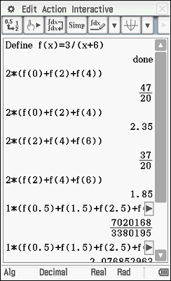
upper limit

lower limit

represents the area under the curve from x = 0 to x= 6, bounded by the x axis. The exact area will lie between the upper limit and lower limit.
Mathematical behaviours | Marks
- shows a calculation to determine an upper limit  - shows a calculation to determine a lower limit  - explains the limits in terms of area | 1  1  1

Question 14 (b) (1 mark)
Solution
Using more rectangles would enable the rectangles to more closely approximate the shape of the function. Hence the error involved in approximating is less and the interval obtained will decrease.
Mathematical behaviours | Marks
- explains why the interval will decrease | 1

Question 14 (c) (1 mark)
Solution
Mathematical behaviours | Marks
- states correct answer to 4 significant figures | 1

Question 15 (6 marks)
Solution
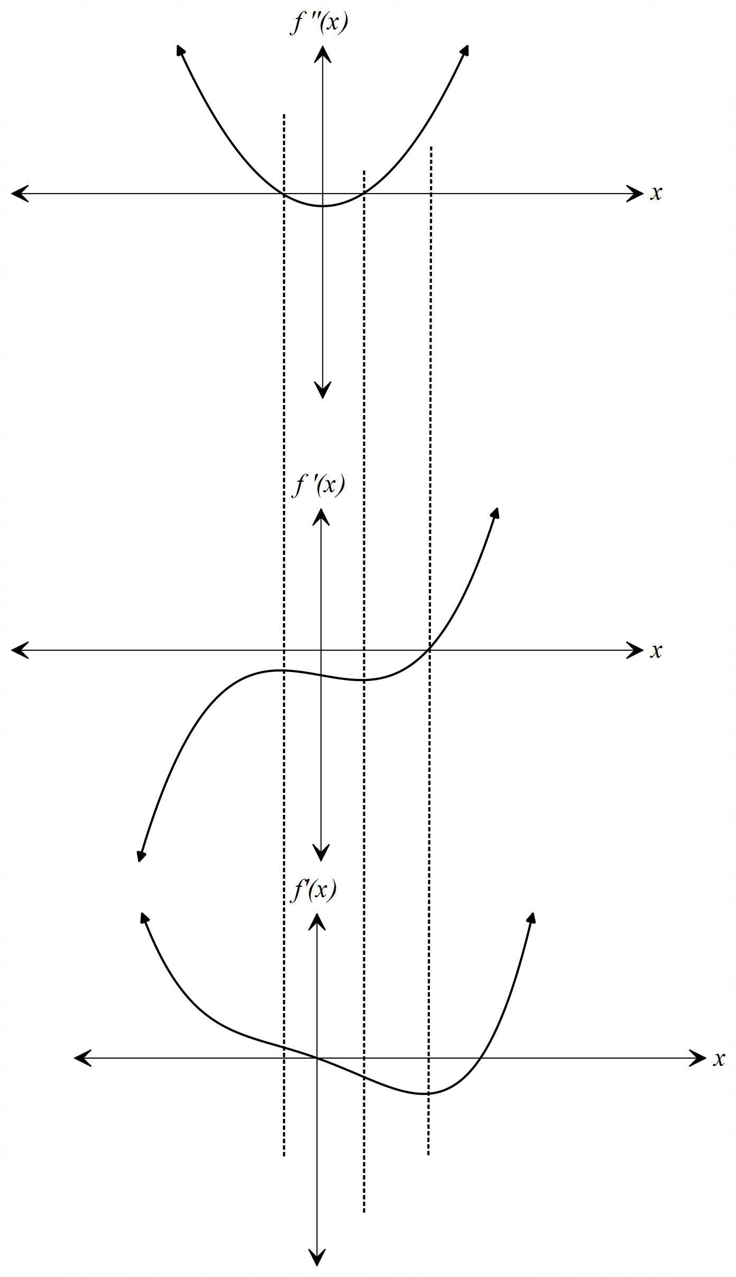
Mathematical behaviours | Marks
For  - point of inflection is on y axis  - maxima/minima align with roots of  - correct shape  For f(x)  - stationary points align with x-intercepts from f ‘(x)  - points of inflection align with the roots of  - correct shape | 1  1  1  1  1  1

Question 16 (a) (2 marks)
Solution
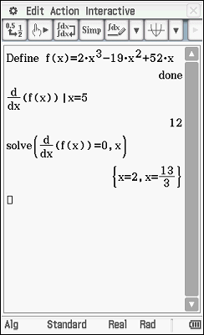
The rate of change of displacement with
respect to time at 5 seconds is 12 m/s.
Mathematical behaviours | Marks
- determines s’(t)  - determines the rate of change with units | 1  1

Question 16 (b) (3 marks)
Solution

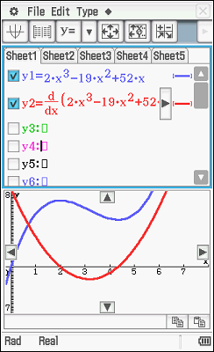

Mathematical behaviours | Marks
- solves  - demonstrates  - states interval with correct symbols | 1  1  1

Question 17 (a) (3 marks)
Solution
$$x$$ | $$P(A=x)$$
$$0$$ | $\left(\begin{matrix}2 \\ 2\end{matrix}\right)÷10=1/10$
$$1$$ | $$\left(\begin{matrix}2 \\ 1\end{matrix}\right)\left(\begin{matrix}3 \\ 1\end{matrix}\right)÷10=6/10$$
$$2$$ | $$\left(\begin{matrix}3 \\ 2\end{matrix}\right)÷10=3/10$$
The required probabilities are the ratios of the numbers of favourable choices to the number of all possible choices.
The number of all possible choices is $\left(\begin{matrix}5 \\ 2\end{matrix}\right)=10$

Mathematical behaviours | Marks
- uses combinations to determine numerators  - uses combinations to determine denominators  - evaluates all probabilities | 1  1  1

Question 17 (b) (3 marks)
Solution
$$E\left(A\right)=0×0.1+1×0.6+2×0.3=1.2$$
$$E\left(A^{2}\right)=0×0.1+1×0.6+4×0.3=1.8$$
So $Var\left(A\right)=E\left(A^{2}\right)-{E\left(A\right)}^{2}=1.8-1.44=0.36$
In summary, the expected value of $A$ is 1.2 and the variance is 0.36

Mathematical behaviours | Marks
- evaluates $E\left(A\right)$  - evaluates $E(A^{2})$  - evaluates $Var(A)$ | 1  1  1

Question 17 (c) (3 marks)
Solution
$B$ has a binomial distribution because it represents the sum of two independent trials (choosing mugs) with the same probability of ‘success’ in each trial
$A$ does not have a binomial distribution because the trials are not independent, i.e. the outcome of the first trial affects the probabilities in the second trial

Mathematical behaviours | Marks
- independence of trials noted (for $B)$  - unchanged probabilities noted (for $B$)  - probabilities for the second choice affected by the outcome of the first  choice (for $A)$ | 1  1  1

Question 17 (d) (5 marks)
Solution
$$x$$ | $$P(C=x)$$
$$2$$ | $$\frac{3}{5}×\frac{2}{4}=3/10$$
$$3$$ | $$\frac{6}{10}×\frac{2}{3}=4/10$$
$$4$$ | $$\frac{3}{10}×\frac{2}{2}=3/10$$
The correct answer is the expected value of $C.$
$C=x$ if and only if the $x^{th}$ mug chosen is unchipped and exactly 1 of the previous $n-1$ chosen mugs is unchipped. So

So $E\left(C\right)=2×0.3+3×0.4+4×0.3=3$
So Caitlin can expect to choose, on average, 3 mugs.
Mathematical behaviours | Marks
- recognizes $E(C)$ as the correct answer  - evaluates individual probabilities  - evaluates | 1  1+1+1  1

Solution
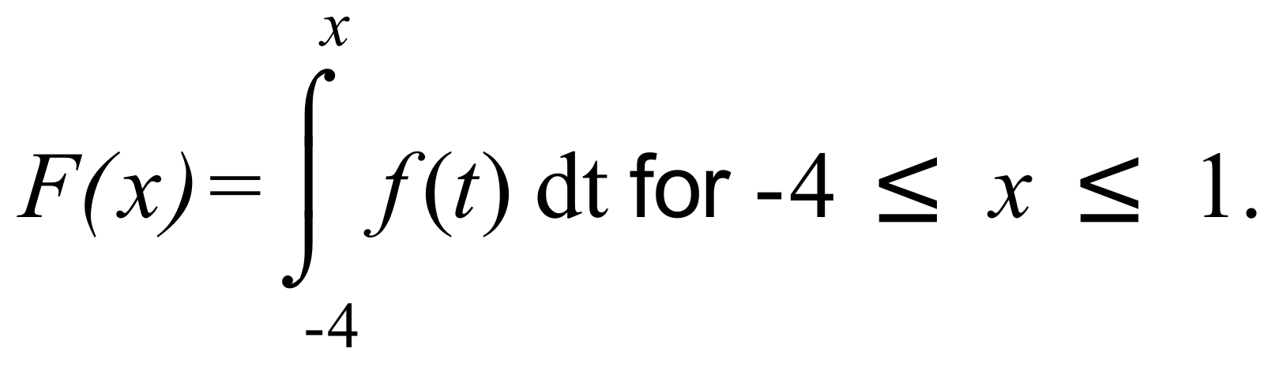
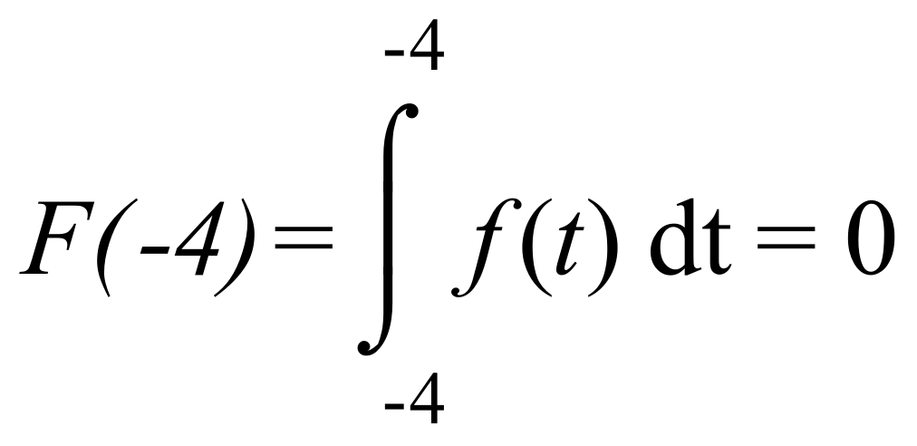
Mathematical behaviours | Marks
- determines | 1
Question 18 (a) (1 mark)

Solution
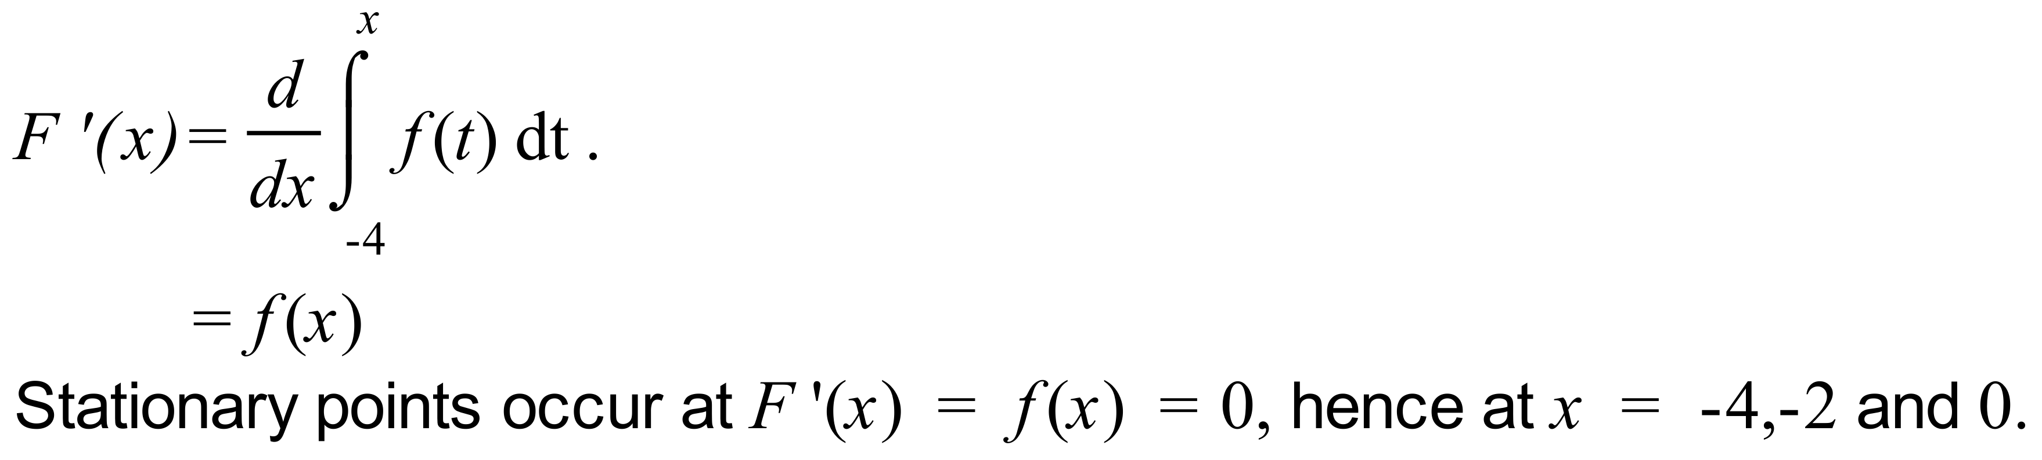
Mathematical behaviours | Marks
- recognizes and applies the fundamental theorem  - identifies three stationary points | 1  1
Question 18 (b) (2 marks)

Solution
Mathematical behaviours | Marks
- identifies one interval for which F is increasing  - states, with correct symbols, both intervals for which F is increasing | 1  1
Question 18 (c) (2 marks)

Solution
Where points of inflection occur 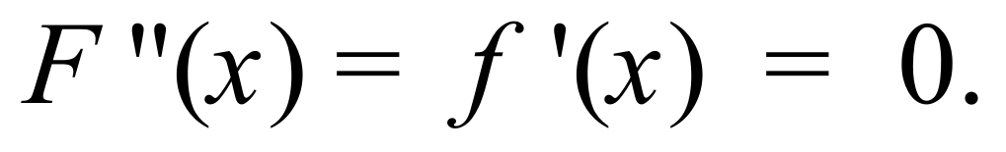Hence 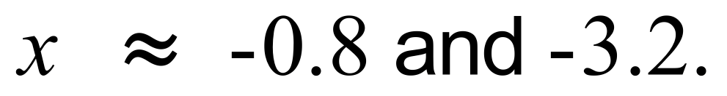
Mathematical behaviours | Marks
- states   - states the approximate x value () of both stationary points | 1  1
Question 18 (d) (2 marks)

Solution
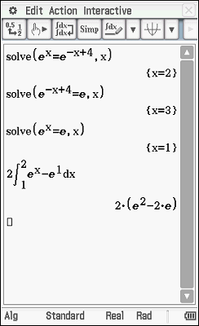
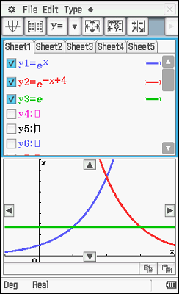
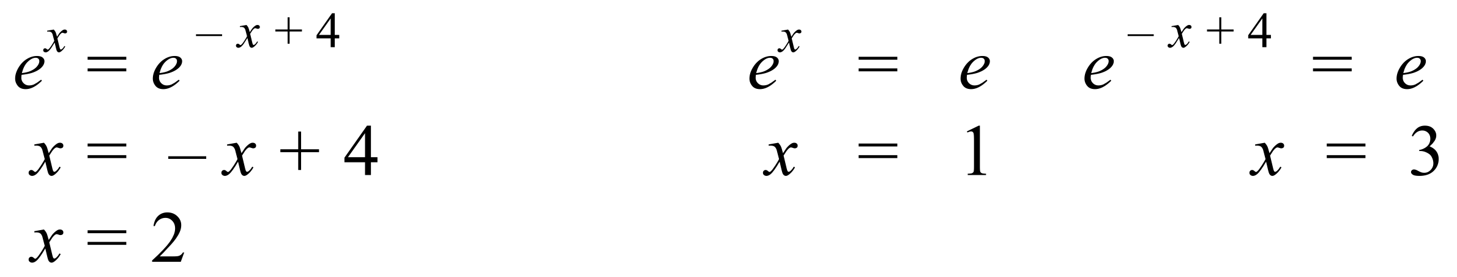

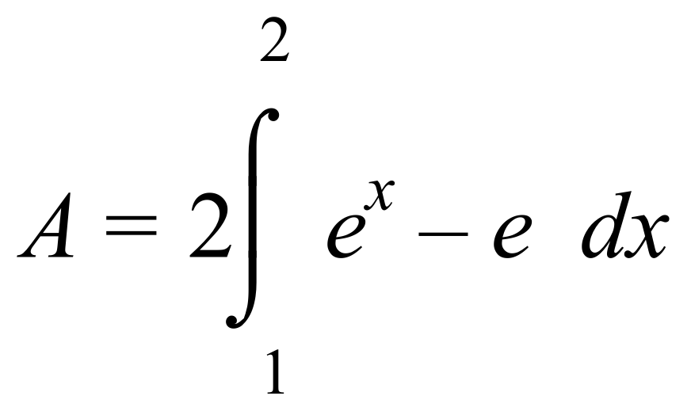

Mathematical behaviours | Marks
- determines one x co-ordinate of intersections  - determines all x co-ordinates of intersections  - states appropriate integral to determine area  - determines exact area | 1  1  1  1
Question 19 (4 marks)

Solution
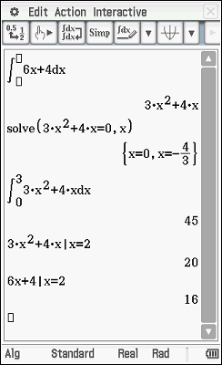
Mathematical behaviours | Marks
- anti-differentiates correctly  - uses initial conditions to establish c = 0 | 1  1
Question 20 (a) (2 marks)

Solution

If the particle changes direction,

Hence it does not change direction
Mathematical behaviours | Marks
- equates  - solves equation and states that particle does not change direction | 1  1
Question 20 (b) (2 marks)

Solution

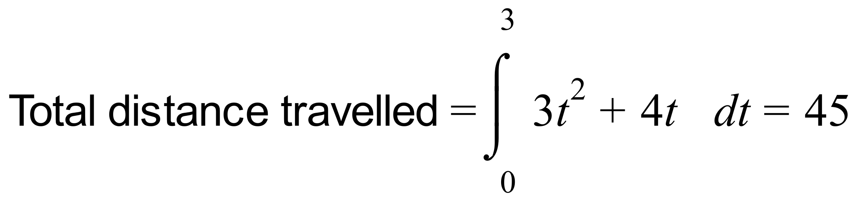
Hence average speed = 15ms⁻¹
Mathematical behaviours | Marks
- states integral required to determine total distance travelled  - determines average speed | 1  1
Question 20 (c) (2 marks)

Question 20 (d) (2 marks)
Solution

Hence the particle is moving with a
positive velocity and is gaining speed

Marking key/mathematical behaviours | Marks
- evaluates at least one of v(2) and  - states the particle is moving with a positive velocity/to the right and is speeding up | 1  1

Question 21 (a) (1 mark)
Solution
Mathematical behaviours | Marks
- determines expression | 1

Question 21 (b) (4 marks)
Solution
Mathematical behaviours | Marks
- differentiates expression  - uses and  - obtains expression for  - determines approximate increase in metal required including unit | 1  1  1  1

Question 22 (a) (2 marks)
Solution
In the northern hemisphere highest temperatures occur in the middle of the year, whereas in the southern hemisphere highest temperatures occur at the beginning and end of the year. Since the data show high temperatures in the middle of the year, the city is more likely to be in the northern hemisphere.
Mathematical behaviours | Marks
- states more likely hemisphere  - valid reasoning | 1  1

Question 22 (b) (2 marks)
Solution
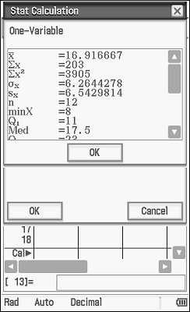
The average maximum temperature values are
$8, 8, 10, 13, 18, 22, 25, 25, 24, 21, 17 \text{and} 12.$
Mean = $16.92$
So the estimated average maximum temperature
is $16.92℃$

Mathematical behaviours | Marks
- states an appropriate calculation to determine the mean  - determines the mean | 1  1

Question 22 (c) (2 marks)
Solution
The estimated standard deviation of the temperatures is $6.26℃.$
Mathematical behaviours | Marks
- determines the standard deviation  - states standard deviation to at least 1 decimal place | 1  1

Question 22 (d) (2 marks)
Solution
The estimated average maximum temperature is $16.92×1.8+32≈62.46℉$
The estimated standard deviation is $6.26×1.8≈11.27℉$
Mathematical behaviours | Marks
- states average in °F  - states standard deviation in °F | 1  1

Question 22 (e) (2 marks)
Solution
In the model $y=A-B\cos\left(\frac{πt}{6}-0.84\right)$ the average value is $A,$ and the values range from $A-B$ to $A+B.$ So $A≈17$ and $B≈9$
Mathematical behaviours | Marks
- determines A  - determines B | 1  1

Question 22 (f) (2 marks)
Solution
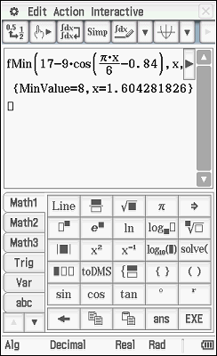
$y=A-B\cos\left(\frac{πt}{6}-0.84\right)$has a minimum when
$\frac{πt}{6}-0.84=0,$ i.e. $t≈1.6$
The nearest integer value is $2.$ So according to
the model, the maximum daily temperatures are
least when $t=2,$ i.e. in February.
Mathematical behaviours | Marks
- obtains $t≈1.6$  - states the lowest maximum is reached in February | 1  1

